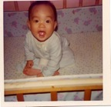
My Family Tree
Before I was Born
After I was Born
I was born on February 5, 1971 in NY, NY
My dad was born on October 1, 1942
in Canton, China
My mom was born on March 3, 1946
in Canton, China
1970
1940
1950
1960
1980
1990
1930
2000
My dad went to Fifth Grade in Canton, China
1952
My mom went to Fifth Grade in Hong Kong
1956
I went to Fifth Grade in Staten Island, NY
1981
By R. Fong, 2009
In the original document, these would hyperlink to .kmz files, which would automatically open up Google Earth and take you to those locations. Here, they are hyperlinked to snapshots of Google Earth.



